**Course Methods test 4 Year 12**

Student name: ________________ Teacher name: ________________

**Task type: Response**

**Time allowed for this task: ___40________ mins**

**Number of questions: ____6_______**

**Materials required:** Calculator with CAS capability (to be provided by the student)

Standard items: Pens (blue/black preferred), pencils (including coloured), sharpener, correction fluid/tape, eraser, ruler, highlighters

Special items: Drawing instruments, templates, notes on one unfolded sheet of   
A4 paper, and up to three calculators approved for use in the WACE examinations

**Marks available: ___45___ marks**

**Task weighting: _10___%**

**Formula sheet provided: Yes**

**Note: All part questions worth more than 2 marks require working to obtain full marks**

Q1 (3 marks)

Mary who goes to Perth Modern scored 67% in her exam which had a mean of 65% and a standard deviation of 18%. John who goes to Rossmoyne scored 62% in an exam with a mean of 58% and a standard deviation of 12%. Using standard scores, explain who had the better result.

Q2 (3 marks)

Given that  and that  , determine the value of  to two decimal places.

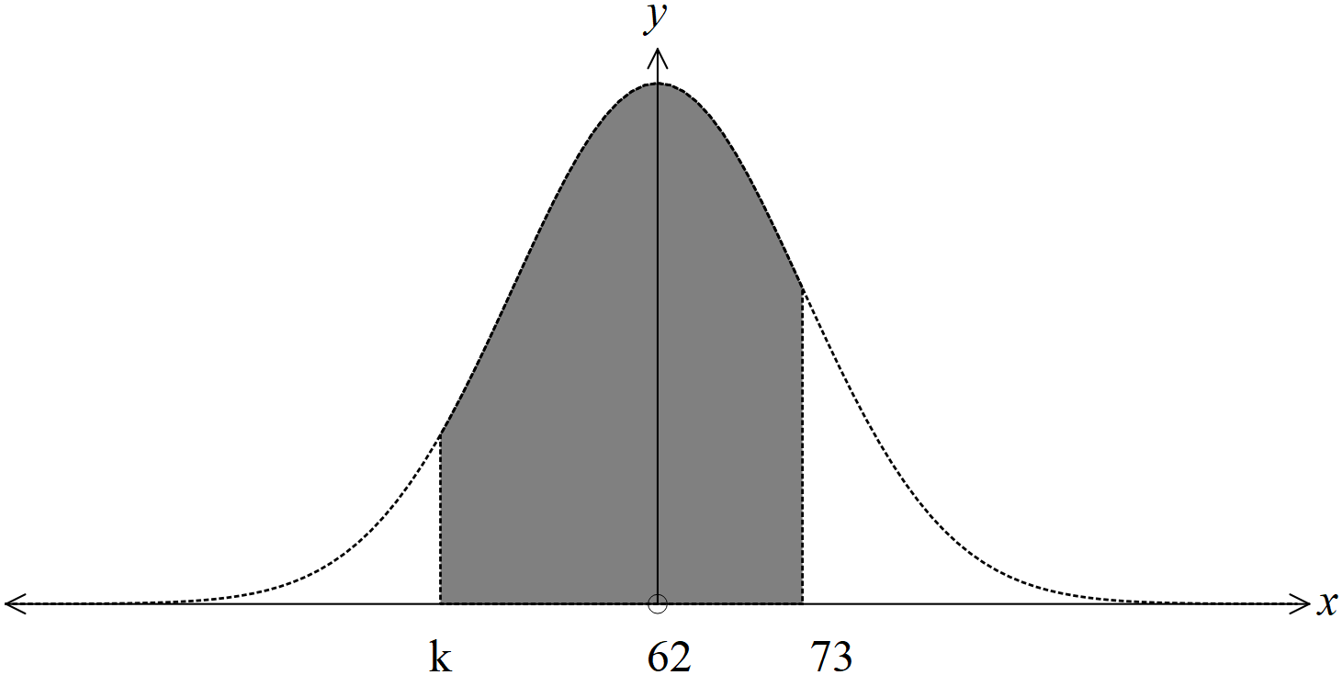

Q3 (10 marks)

The lengths of telephone calls,  in minutes, in Perth are Normally distributed with . Calls that are longer than 17 mins are charged at double rate and are known as SUPER calls.

1. Determine the proportion of calls that are between 11 and 17 mins. (2 marks)
2. Given that a call is less than 13 mins, determine the probability that the call is greater than

9 mins. (3 marks)

1. If the length of the call is in the lower 20% of calls, the call is not charged at all. Determine the longest length of call that is not charged to **the nearest second**. (2 marks)
2. In Sydney the calls are also Normally distributed with a mean of 19 mins. If 25% of all calls are greater than 24 mins, determine the standard deviation to two decimal places. (3 marks)

Q4 (15 marks)

In a particular city it is estimated that 30% of the population have blue eyes. A sample of 250 people is chosen and the number of blue eyed people are counted. The statistician will assume a Binomial distribution.

1. State two reasons why the statistician **believes** that a Binomial distribution is appropriate.

(2 marks)

1. Determine the probability that at least 75 people of the sample have blue eyes. (2 marks)

For each sample of 250 people the number of blue eyed people are counted and a sample proportion is calculated.

1. State the **approximate** distribution of these sample proportions including all features.

(2 marks)

1. Determine the approximate probability that a sample proportion will be greater than 0.35.

(2 marks)

1. One sample of 250 people had 65 with blue eyes. Determine a 90% confidence interval for the population proportion to 3 decimal places. (3 marks)

Q4 cont

1. Another three samples of 250 people were taken and the number of blue eyed people were counted. See below. One of these samples is not from the city above (e). Explain which sample it is and justify your answer using confidence intervals (4 marks)

|  |  |
| --- | --- |
| Sample | Number of blue eyed people |
| A | 55 |
| B | 72 |
| C | 41 |

Q5 (2, 2 & 3 = 7 marks)

Consider a 90% confidence interval that has a margin of error of  units. Assume that the sample proportion does not change.

Answer in terms of .

1. Determine the new margin of error if the sample size is nine times the original.
2. Determine the new margin of error if the sample size is unchanged but the confidence is decreased to 75%. (2 decimal places).
3. Determine the new width of the confidence interval if a confidence of 97% is used and the sample size being one third of the original size. (2 decimal places)

Q6 (7 marks)

A traffic consultant has been hired to determine the proportion of people who drive to work.

1. A confidence interval of 82% will be used with an error within 0.015. Determine the minimum sample size that should be selected. (3 marks)
2. If the maximum sample size is 720 people, determine the maximum error in estimating a 95% confidence interval. (2 marks)
3. The consultant will stand outside a train station and will interview every fourth person who enters. Describe two sources of bias with this sampling scheme. (explain). (3 marks)

**Extra working space**